7. Develop a system using UML for implementing Credit Card Processing System. In this system, the cardholder can purchase items and pays the bill with the aid of a credit card. The cashier should accept the card and proceed with the transaction using the central system. The bill is to be verified and the items are delivered to the cardholder based on it.

CLASS DIAGRAM:

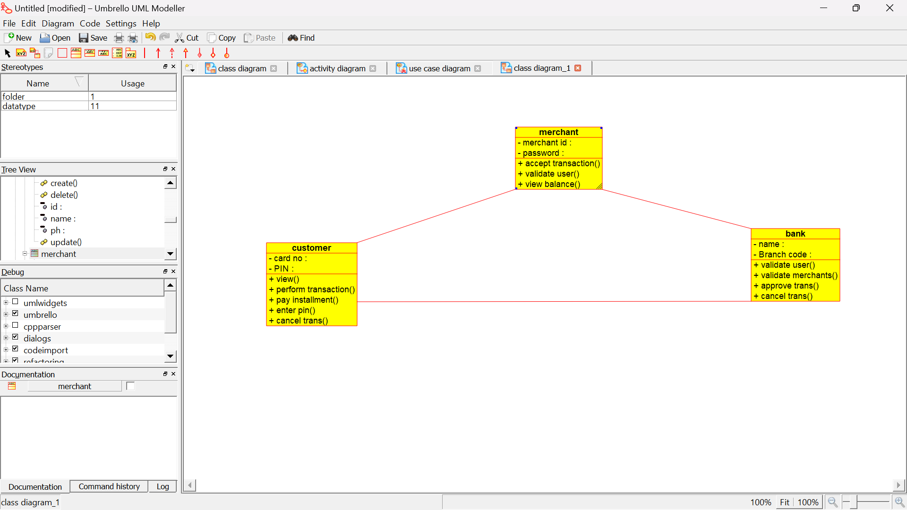

USECASE DIAGRAM:

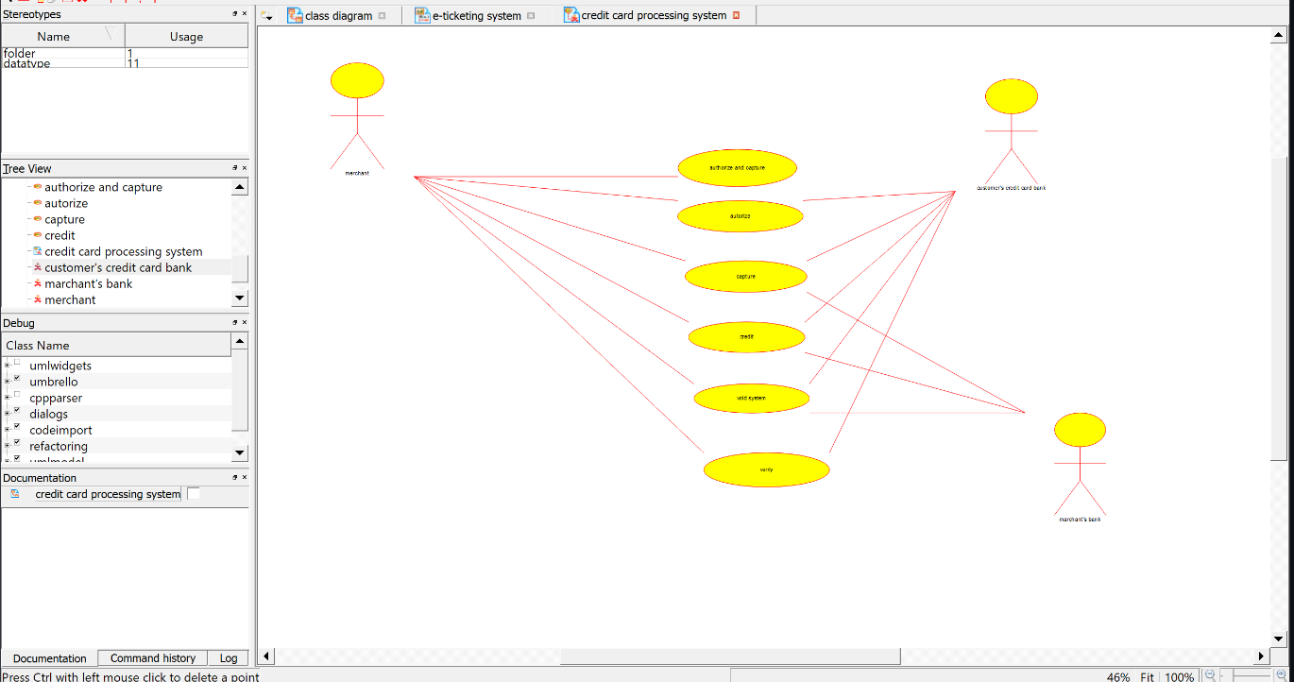

ACTIVITY DIAGRAM:

